|  |  |  |  |  |
| --- | --- | --- | --- | --- |
|  | Question | t-statistic | p-value | Effect size |
| 0 | Gender based violence is violence directed at an individual based on his or biological sex. | 0.000 | 1.000 | 0.000 |
| 1 | Does GBV include abuse of men? | 0.724 | 0.472 | -0.121 |
| 2 | Is Bullying a form of GBV? | -1.477 | 0.146 | 0.284 |
| 3 | Actions that deny an Individual access to basic necessities like freedom, food and health care is a form of violence. | -0.207 | 0.837 | 0.040 |
| 4 | A man has a right to assert power over a woman and is socially superior to above. | -1.353 | 0.182 | 0.242 |
| 5 | A man has a right to â€œcorrectâ€ or discipline female behavior | -0.240 | 0.811 | 0.040 |
| 6 | Children who witness violence at home have a tendency to be violent in future. | 0.596 | 0.554 | -0.120 |
| 7 | Sexual violence e.g rape is an acceptable way of putting women in their place or punishing them. | -1.043 | 0.302 | 0.201 |
| 8 | A girl who dresses indecently should be raped. | 0.535 | 0.595 | -0.121 |
| 9 | Boys can be sexually exploited? | -1.593 | 0.118 | 0.327 |
| 10 | STI, HIV/AIDS, unwanted pregnancy, trauma, disability, low self-esteem, depression and suicide are consequences of gender based violence. | 0.962 | 0.341 | -0.201 |
| 11 | Females should be denied access to financial resources? | -0.573 | 0.569 | 0.121 |
| 12 | A victim of gender based violence should be blamed? | 0.000 | 1.000 | 0.000 |
| 13 | Intimate partner violence is a taboo subject and reporting abuse is disrespectful? | -1.181 | 0.243 | 0.243 |
| 14 | GBV is the fault of the offender or doer? | -0.423 | 0.674 | 0.080 |
| 15 | A male has the right to hit a female that disrespects or insult him? | 0.389 | 0.699 | -0.081 |
| 16 | Victims of GBV should report it | 0.651 | 0.518 | -0.122 |
| 17 | Victims of GBV should seek adequate care and help. | 1.769 | 0.083 | -0.370 |
| 18 | A female has the right to hit a male who disrespects or insults her? | -0.389 | 0.699 | 0.080 |

**Summary of the result table**:

* The table reports the **t-statistic**, **p-value**, and **effect size** for each question, which are statistical measures of the difference between the responses of male and female participants.
* A positive t-statistic indicates that males scored higher than females on the question, while a negative t-statistic indicates the opposite. A p-value less than 0.05 indicates that the difference is statistically significant, meaning it is unlikely to be due to chance. Effect size measures the magnitude of the difference, with larger absolute values indicating larger differences.
* Based on the table, none of the questions showed a statistically significant difference between male and female responses, as all the p-values were greater than 0.05. However, some questions showed moderate to large effect sizes, such as question 2 (Is bullying a form of GBV?), question 9 (Boys can be sexually exploited?), and question 17 (Victims of GBV should seek adequate care and help?). These questions suggest that there may be some gender differences in the perception of GBV, but more data is needed to confirm this.

**Hypothesis testing**

Null Hypothesis: There is no statistical significant difference between the knowledge of pre intervention and post intervention.

Alternate Hypothesis: There is a statistical significant difference between knowledge of pre intervention and post intervention.

Result from the analysis:

1. Cannot reject the null hypothesis for Gender based violence is violence directed at an individual based on his or biological sex.; there is no statistically significant difference between the pre-intervention and post-intervention scores.
2. Cannot reject the null hypothesis for Does GBV include abuse of men?; there is no statistically significant difference between the pre-intervention and post-intervention scores.
3. Cannot reject the null hypothesis for Is Bullying a form of GBV?; there is no statistically significant difference between the pre-intervention and post-intervention scores.
4. Cannot reject the null hypothesis for Actions that deny an Individual access to basic necessities like freedom, food and health care is a form of violence.; there is no statistically significant difference between the pre-intervention and post-intervention scores.
5. Cannot reject the null hypothesis for A man has a right to assert power over a woman and is socially superior to above.; there is no statistically significant difference between the pre-intervention and post-intervention scores.
6. Cannot reject the null hypothesis for A man has a right to “correct” or discipline female behavior; there is no statistically significant difference between the pre-intervention and post-intervention scores.
7. Cannot reject the null hypothesis for Children who witness violence at home have a tendency to be violent in future.; there is no statistically significant difference between the pre-intervention and post-intervention scores.
8. Cannot reject the null hypothesis for Sexual violence e.g rape is an acceptable way of putting women in their place or punishing them.; there is no statistically significant difference between the pre-intervention and post-intervention scores.
9. Cannot reject the null hypothesis for A girl who dresses indecently should be raped.; there is no statistically significant difference between the pre-intervention and post-intervention scores.
10. Cannot reject the null hypothesis for Boys can be sexually exploited?; there is no statistically significant difference between the pre-intervention and post-intervention scores.
11. Cannot reject the null hypothesis for STI, HIV/AIDS, unwanted pregnancy, trauma, disability, low self-esteem, depression and suicide are consequences of gender based violence.; there is no statistically significant difference between the pre-intervention and post-intervention scores.
12. Cannot reject the null hypothesis for Females should be denied access to financial resources?; there is no statistically significant difference between the pre-intervention and post-intervention scores.
13. Cannot reject the null hypothesis for A victim of gender based violence should be blamed?; there is no statistically significant difference between the pre-intervention and post-intervention scores.
14. Cannot reject the null hypothesis for Intimate partner violence is a taboo subject and reporting abuse is disrespectful?; there is no statistically significant difference between the pre-intervention and post-intervention scores.
15. Cannot reject the null hypothesis for GBV is the fault of the offender or doer?; there is no statistically significant difference between the pre-intervention and post-intervention scores.
16. Cannot reject the null hypothesis for A male has the right to hit a female that disrespects or insult him?; there is no statistically significant difference between the pre-intervention and post-intervention scores.
17. Cannot reject the null hypothesis for Victims of GBV should report it; there is no statistically significant difference between the pre-intervention and post-intervention scores.
18. Cannot reject the null hypothesis for Victims of GBV should seek adequate care and help.; there is no statistically significant difference between the pre-intervention and post-intervention scores.
19. Cannot reject the null hypothesis for A female has the right to hit a male that disrespects or insult her?; there is no statistically significant difference between the pre-intervention and post-intervention scores.

**Graphs**

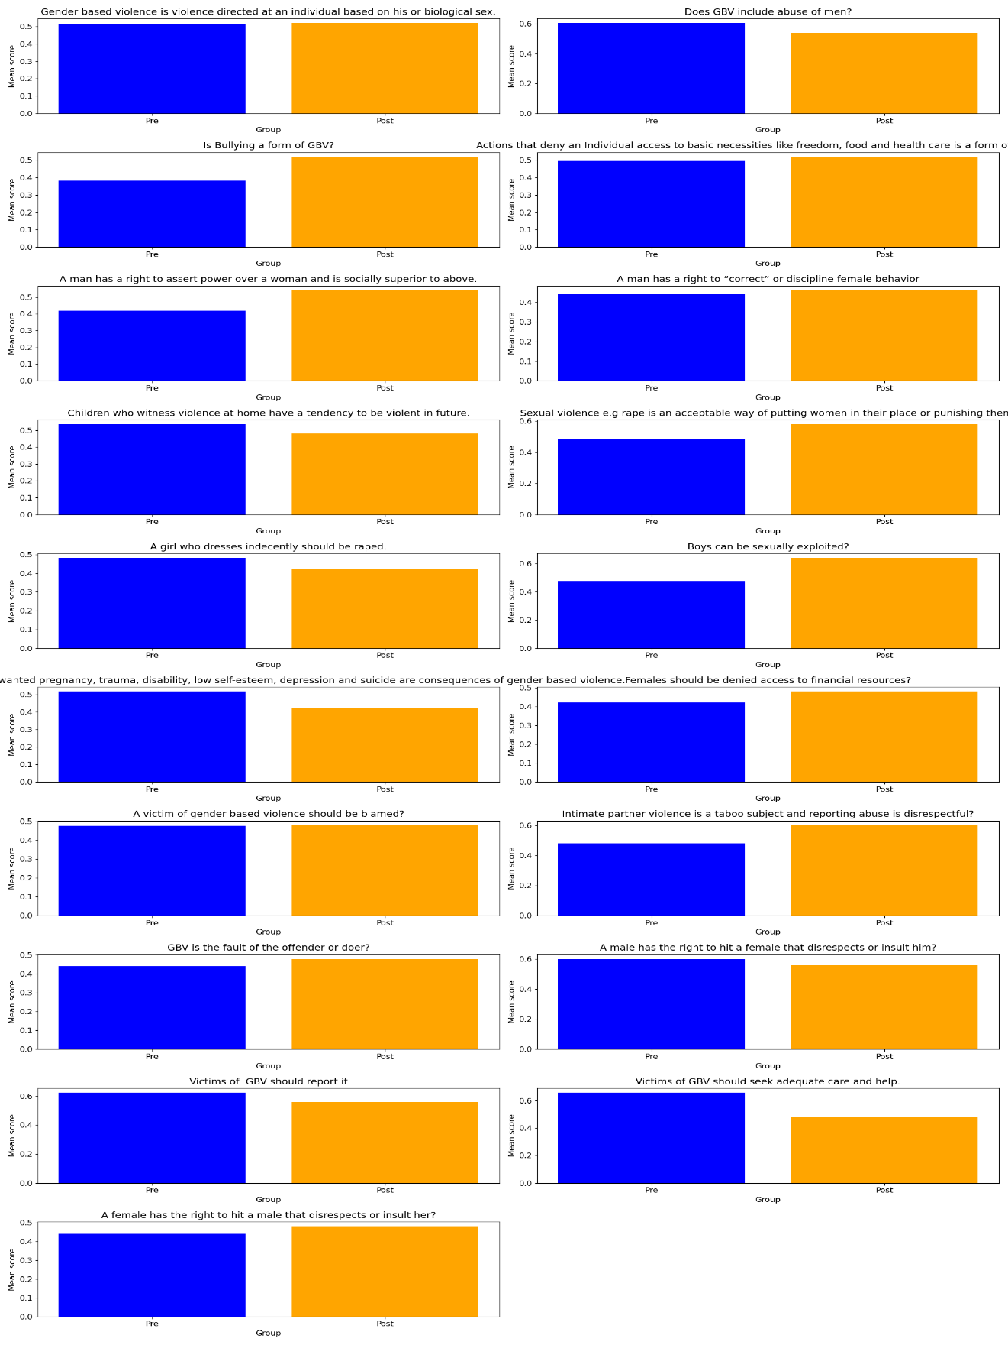

**Observations from the Graphs**

* **Bullying as a form of GBV**: 72% of the respondents agreed that bullying is a form of gender-based violence (GBV) that may deny an individual access to basic necessities like freedom, food, and health care.
* **Men's rights over women**: 64% of the respondents disagreed that a man has a right to assert power over a woman and to be socially superior or subordinate. Only 16% agreed with this statement.
* **Children witnessing violence at home**: 88% of the respondents agreed that children who witness violence at home have a tendency for violent behavior in future. Only 4% disagreed with this statement.
* **Indecent dressing and rape**: 76% of the respondents disagreed that a girl who dresses indecently should be raped. Only 12% agreed with this statement.